Assignment No: 3

**Title:** Parallel Sorting Algorithms- For Bubble Sort and Merger Sort, based on existing sequential algorithms, design and implement parallel algorithm utilizing all resources available.

**Bubble Sort: -**

A way to implement the Bubble Sort in parallel is to divide the domain of the list (more or less) equally between the N-1 nodes 1 to (N-1) of an N nodes parallel machine, keeping node 0 to administer the calculation. Each node 1 to (N-1) can then sort its partial list and send it back to node 0 for a final global merge.

**Program:**

#include<iostream>

#include<stdlib.h>

#include<omp.h>

using namespace std;

void bubble(int *, int);

void swap(int &, int &);

void bubble(int *a, int n)

{

for( int i = 0; i < n; i++ )

{

int first = i % 2;

#pragma omp parallel for shared(a,first)

for( int j = first; j < n-1; j += 2 )

{

if( a[ j ] > a[ j+1 ] )

{

swap( a[ j ], a[ j+1 ] );

}

}

}

}

void swap(int &a, int &b)

{

int test;

test=a;

a=b;

b=test;

}

int main()

{

int *a,n;

cout<<"\n enter total no of elements=>";

cin>>n;

a=new int[n];

cout<<"\n enter elements=>";

for(int i=0;i<n;i++)

{

cin>>a[i];

}

bubble(a,n);

cout<<"\n sorted array is=>\n";

for(int i=0;i<n;i++)

{

cout<<a[i]<<endl;

}

return 0;

}

**Output:**

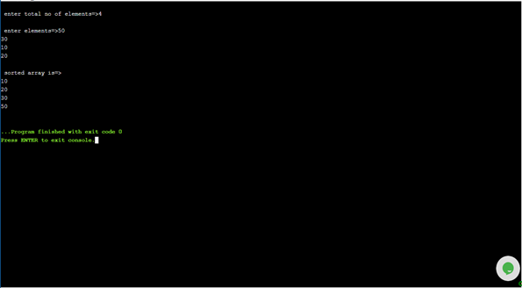

**Merge Sort:**

**Program:**

Merge sort first divides the unsorted list into smallest possible sub-lists, compares it with the adjacent list, and merges it in a sorted order. Like QuickSort, Merge Sort is a Divide and Conquer algorithm. It divides input array in two halves, calls itself for the two halves and then merges the two sorted halves. The merge() function is used for merging two halves. The merge(arr, l, m, r) is key process that assumes that arr[l..m] and arr[m+1..r] are sorted and merges the two sorted sub-arrays into one.

#include<iostream>

#include<stdlib.h>

#include<omp.h>

using namespace std;

void mergesort(int a[],int i,int j);

void merge(int a[],int i1,int j1,int i2,int j2);

void mergesort(int a[],int i,int j)

{

int mid;

if(i<j)

{

mid=(i+j)/2;

#pragma omp parallel sections

{

#pragma omp section

{

mergesort(a,i,mid);

}

#pragma omp section

{

mergesort(a,mid+1,j);

}

}

merge(a,i,mid,mid+1,j);

}

}

void merge(int a[],int i1,int j1,int i2,int j2)

{

int temp[1000];

int i,j,k;

i=i1;

j=i2;

k=0;

while(i<=j1 && j<=j2)

{

if(a[i]<a[j])

{

temp[k++]=a[i++];

}

else

{

temp[k++]=a[j++];

}

}

while(i<=j1)

{

temp[k++]=a[i++];

}

while(j<=j2)

{

temp[k++]=a[j++];

}

for(i=i1,j=0;i<=j2;i++,j++)

{

a[i]=temp[j];

}

}

int main()

{

int *a,n,i;

cout<<"\n enter total no of elements=>";

cin>>n;

a= new int[n];

cout<<"\n enter elements=>\n";

for(i=0;i<n;i++)

{

cin>>a[i];

}

mergesort(a, 0, n-1);

cout<<"\n sorted array is=>";

for(i=0;i<n;i++)

{

cout<<"\n"<<a[i];

}

return 0;

}

**Output:** 